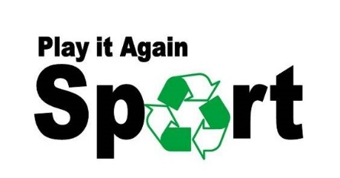
REFERRAL FORM
Please complete the following information on behalf of the person needing sport clothing/equipment. Subject to availability, we will provide sporting equipment/clothing to anyone in need, regardless of age, gender or any other criteria.

Organisation making the referral:
Gender (if relevant):
Size clothes needed (this can be different from the actual age of a child):
Shoe size (if relevant):
Sport type (rugby/netball etc):
Equipment needed (clothing/shoes/balls/racquets):
Any other help required:
(This can be support with club fees, or knowledge of sporting clubs in the local area etc).
Location to be delivered to (please note, this should be an address affiliated with your organisation):

When this form has been completed please send it to:
Natasha.burnell@peopleandwork.org.uk
Any queries please contact Natasha – 07375 894007

Play It Again Sport is a social enterprise and part of People & Work charity, please find further information on our website: www.playitagainsport.wales

Charity number: 515211
Company registration number: 1809654

